Q1. Open MySQL Workbench or CLI and write a CREATE TABLE statement to create a table called 'restaurants' with columns: id (INT, primary key, auto-increment), name (VARCHAR(100)), location (VARCHAR(100)), and rating (DECIMAL(2,1)).
ANS: Query:
USE SESSION2;
CREATE TABLE restaurants(id int PRIMARY KEY AUTO_INCREMENT,name varchar(100),location varchar(100),rating decimal(2,1));
SELECT * FROM restaurants;
Output: .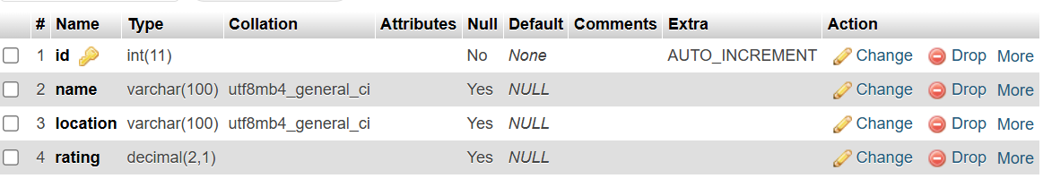
Q.2. Use the ALTER TABLE command in MySQL to add a new column 'average_cost' (INT) to your 'restaurants' table.<br><br><em><strong>Hint:</strong> Remember to specify the data type when adding a new column.</em>
ANS: Query:
ALTER TABLE restaurants ADD COLUMN average_cost int;
Output:
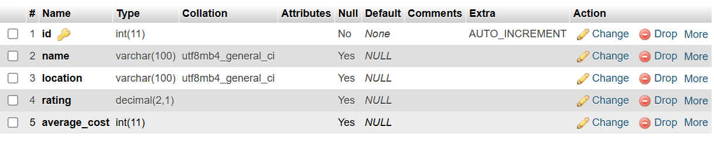
Q.3. Write a SQL statement to DROP the 'restaurants' table you created earlier. Double-check your command before running it to avoid accidental data loss.
ANS: Query:
DROP TABLE restaurants;
Output: 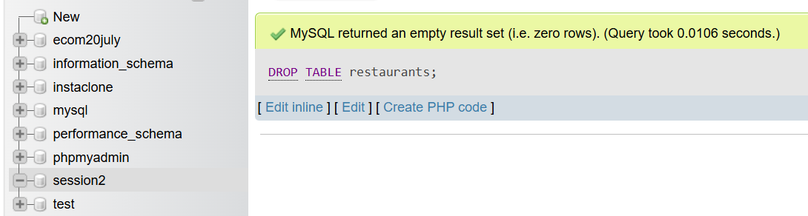
Q.4.Create a new table called 'playlists' for a music app like Spotify, with columns: playlist_id (INT, primary key, auto-increment), title (VARCHAR(50)), created_by (VARCHAR(50)), and created_at (DATE).
ANS :Query:
CREATE TABLE playlists(playlists_id int PRIMARY KEY AUTO_INCREMENT,title varchar(50),created_by varchar(50),created_at date);
SELECT * FROM playlists;
Output: 